REPORT DIAGRAM FOR SIDE PROJECT.

* Student user interface:

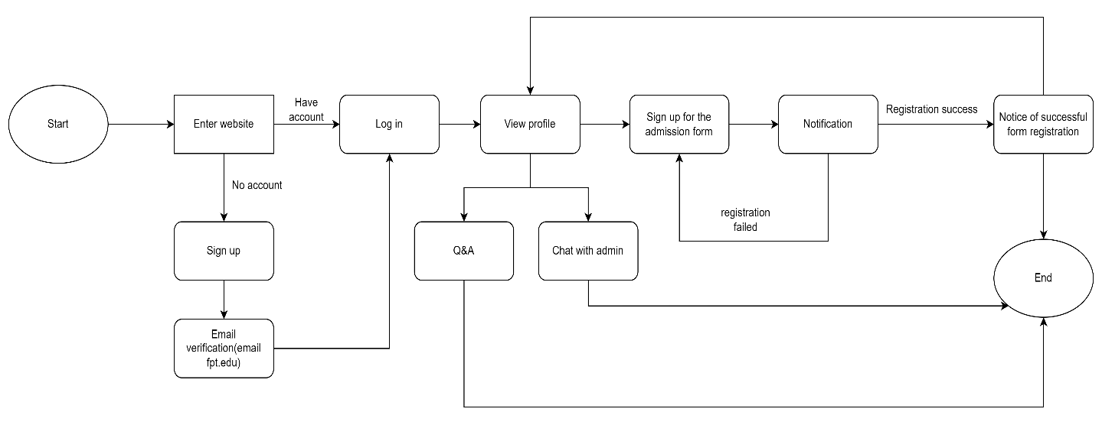

* Admit interface:

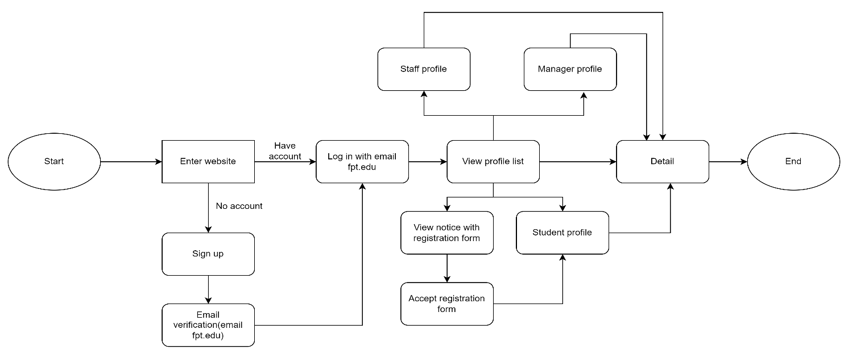

* Admin interface:

